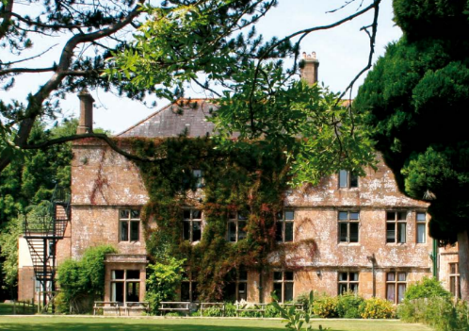
Hooke Court Residential Visit 2022
A Guide for Parents and Pupils
At Piddle Valley CE First School we believe that residential visits form an important part of a child’s personal and social development, as well as developing a feeling of independence and self-reliance. As such our residential has two main aims - personal development and educational development in that it fulfils a key part of the PE curriculum.
It also provides them with memories that will last a lifetime!!

Safety
Your child’s safety is always our first concern. As part of the planning for the visit a detailed risk assessment has taken place. Part of this risk assessment is a code of conduct which we would be very grateful if you could look at with your child before we leave. Where children do not keep to the agreed code of conduct they may be sent home.
As part of the induction at Hooke Court we shall have a fire safety talk.
Your child will be supervised at all times.
At night the children will be secure in their rooms and school staff rooms will be spaced along their corridors. The school staff will also have told the children where the staff rooms are and how to contact staff if needed.
All centre staff have a current DBS and the centre is secured at night. The centre has full links with the local GP.
Preparation
For some this may be their first time away, whilst others may be more experienced travellers! Whatever the case there will be some anxiety and we are sensitive to this. To help your child have a successful and enjoyable time we offer the following guidance.
- Ensure that they fully understand the code of conduct.
- Pack a reminder of home, a teddy or picture.
- Involve them in packing; they will need to pack themselves on Friday!
- Ensure they can carry their luggage themselves!
- Tell us if there is a birthday or special event during the visit.
- Be prepared for tired children!

Programme
We will leave school and travel to Hooke Court on Wednesday morning. You should therefore arrive at school at normal time, if it is wet we will put bags in the hall.
We will depart school at 9:30am, to arrive at Hooke Court for approximately 10:30am.
We shall arrive back at school on Friday at 2:30pm. If your child is using the normal school bus at the end of the day please let us know.

Electronics
All the staff will be taking lots of photographs so cameras aren’t needed as photographs will be available to look at on our website.
Please do not send your child with any electronic games or mobile phones.

Medicines
We will take all the medical details for your child that we have on our school records. If there is any additional information that we need to be aware of please use the accompanying forms. All medicines need to be handed to Mrs Lock on Wednesday morning.

Contact Details
Please note that we do not want the children to use the phone to contact home. If there is a real need for us to contact you we will phone you immediately, so you can safely assume that no news is good news!
If you need to contact us we would ask you do it through the school.
However, if the school is closed then the contact details for Hooke Court are:
Hooke Court
Hooke
Dorset
DT8 3NX
Tel: 01308 862260
Email – info@hookecourt.co.uk
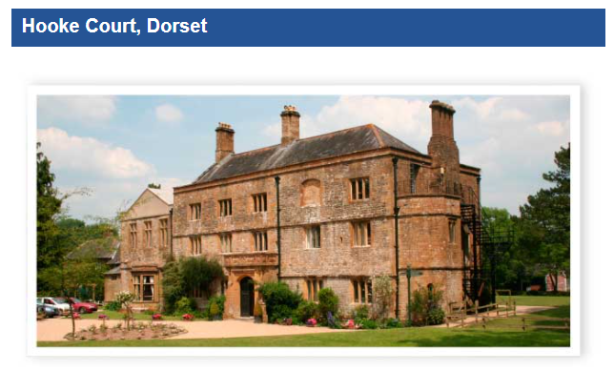
If you have any further questions please do not hesitate to speak to Mrs Browne, Mrs Nelson or Mrs Lock.

