Rapid Recall
Mental calculation
Bar Model
MULTIPLICATION AGE-RELATED
Recording

EXPECTATIONS
YR | Count repeated groups of the same size (1s / 2s / 5s / 10s)  ref Overview of learning 5 | Practical / recorded using ICT (eg digital photos / pictures on IWB) | Pictures / Objects  3 plates, 2 cakes on each plate: |  |  |  |  |  |  |  | Symbols  3 plates, 2 cakes on each plate: |  |  |  |  | 2 + 2 + 2 |  | Counting on in 1s and 2s | Counting in 2s
KS1 | Solve (practical) problems that involve combining groups of 2, 5 or 10 | Practical / recorded using ICT | Pictures / Symbols  There are three sweets in one bag.  How many sweets are there in five bags? |  |  |  | Number tracks / Number line  (modelled using bead strings)  2 x 3 or 3 x 2  [two groups of three] or [three groups of two]  2  4  4  2  6  0 |  |  |  |  |  |  |  |  | 2 2 2  3 x 2 = |  | Count on / back in 1s, 2s, 5s and 10s  Doubles of all numbers to 10 + corresponding halves (see division) | Counting in 2s, 5s and 10s
KS1 | Multiplication as repeated addition and arrays  Multiplication is commutative(any order) | Pictures / Symbols  There are four apples in each box.  How many apples in six boxes |  |  | Repeated addition  5 x 3 or 3 x 5  0 3 6 9 12 15  0 5 10 15  [ref Multiplication facts ITP] |  |  |  |  |  |  | Arrays  5 x 3 or 3 x 5  Also 14 x 2 as (10 x 2 and 4 x 2) |  |  |  | If three children have 15p each how much money do they have altogether?  15  10  5  x3=30 x3=15  30 + 15 = 45 |  | Count in 2s, 5s and 10s  Doubles of numbers to 20 | Doubles of TU numbers  Derive multiples of 2, 5 & 10  Relate to x facts (and derive related ÷ facts)
  15 | 15 | 15
Lower  KS2  Estimate first | TU x U  (eg 13 x 4) | Arrays  13 x 4  10 x 4 = 40  3 x 4 = 12 [ref Arrays spreadsheet] |  |  |  |  |  | Expanded grid method  13 x 4 |  |  |  | Compact grid method  13 x 4 |  | Partitioning  13 x 4 = 52  10 x 4 = 40  3 x 4 = 12 |  |  |  | Recall 2, 3, 4, 8 and 10 times tables  (Derive related division facts)  Recognise multiples of 2, 5 and 10 up to 1000  Doubles of multiples of 50 to 500 | U / TU x 10 / 100 (describe the effect)  Doubles of TU / HTU numbers  Derive times tables  Multiply by 0/1
  x | 10 | 3
  4 | 40 | 12
Lower  KS2  Estimate first | Record, support and explain:  TU x U  (eg 16 x 8; 43 x 6) | Partitioning  43 x 6  (estimate: 40 x 6 = 240)  40 x 6 = 240  3 x 6 = 18 |  | Compact grid method  43 x 6  18  240  6  3  40  X |  |  |  |  | Expanded vertical  43  x 6  18 ( 3 x 6)  240 (40 x 6)  258 |  |  |  | Compact vertical  43  x 6  258  1 |  |  | Joe has 14 sweets. Andy has 3 times as many as Joe. Fred has half as many as Andy.  How many do they have altogether?  14 x 4 = + 7 =  Method as needed |  | Derive / recall all facts to 12 x 12  Recognise and use factor pairs | Numbers up to 1000 x 10 / 100  (understand the effect)  Multiply 3 numbers
  14
  14 |  | 14 | 14
  7
Y5 | Refine and use efficient methods:  ThHTU x U  (e.g 2347 x 8)  ThHTU x TU  Decimal (1dp) x U  (e.g 3.6 x 7) | Grid method  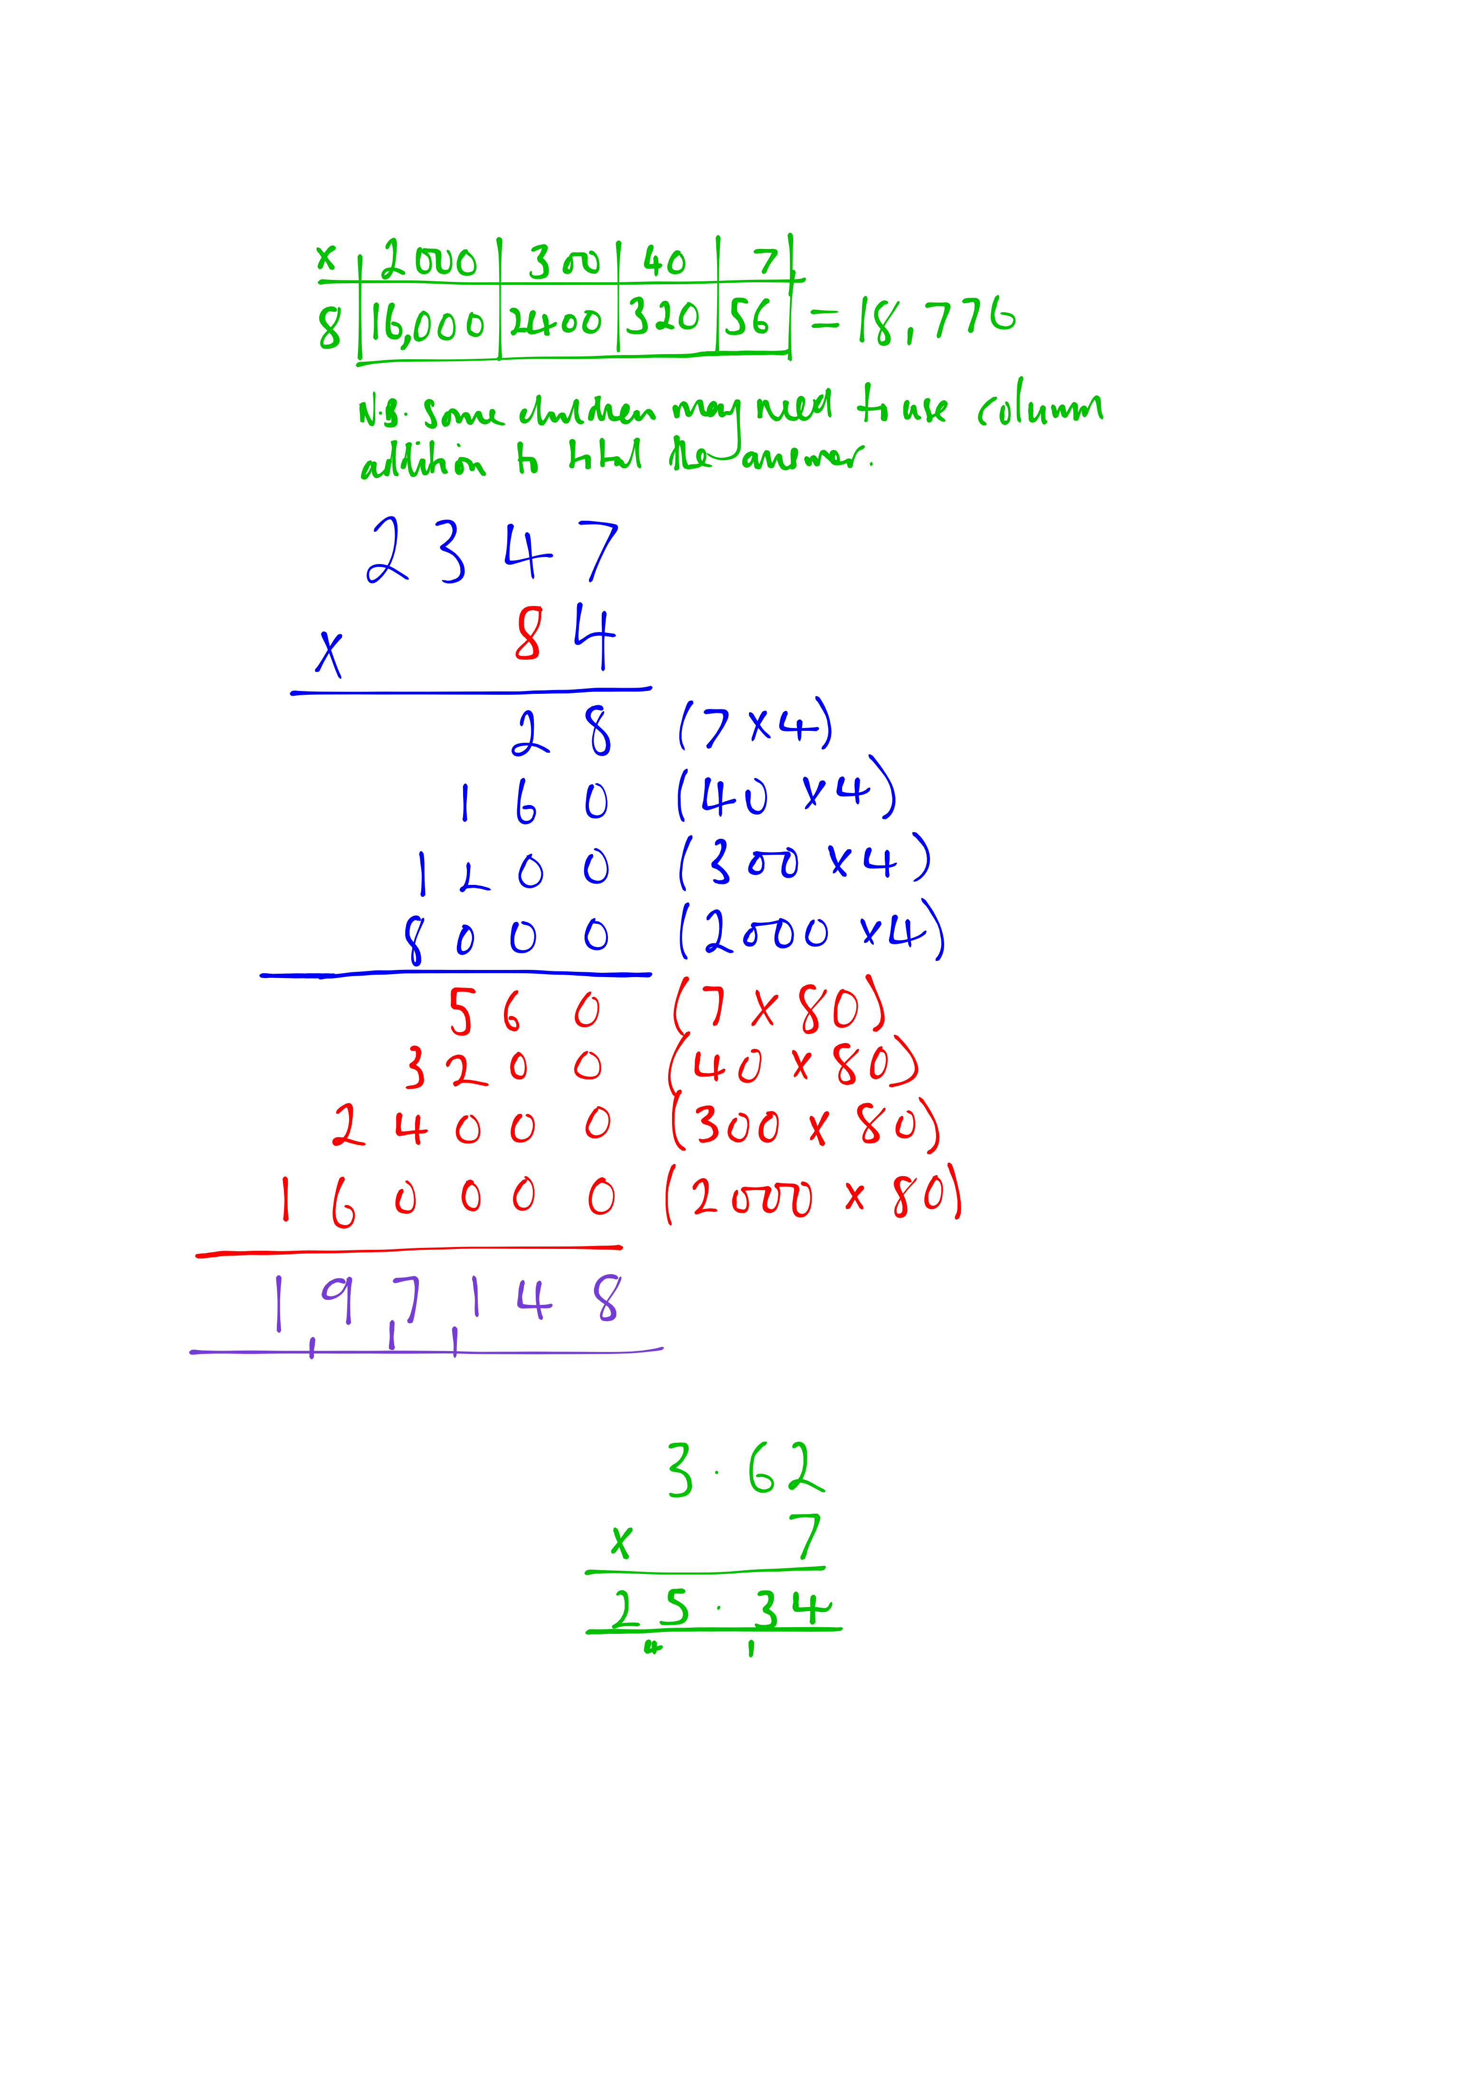  N.B. some children may need to use column addition to total the answer |  |  |  | Expanded vertical  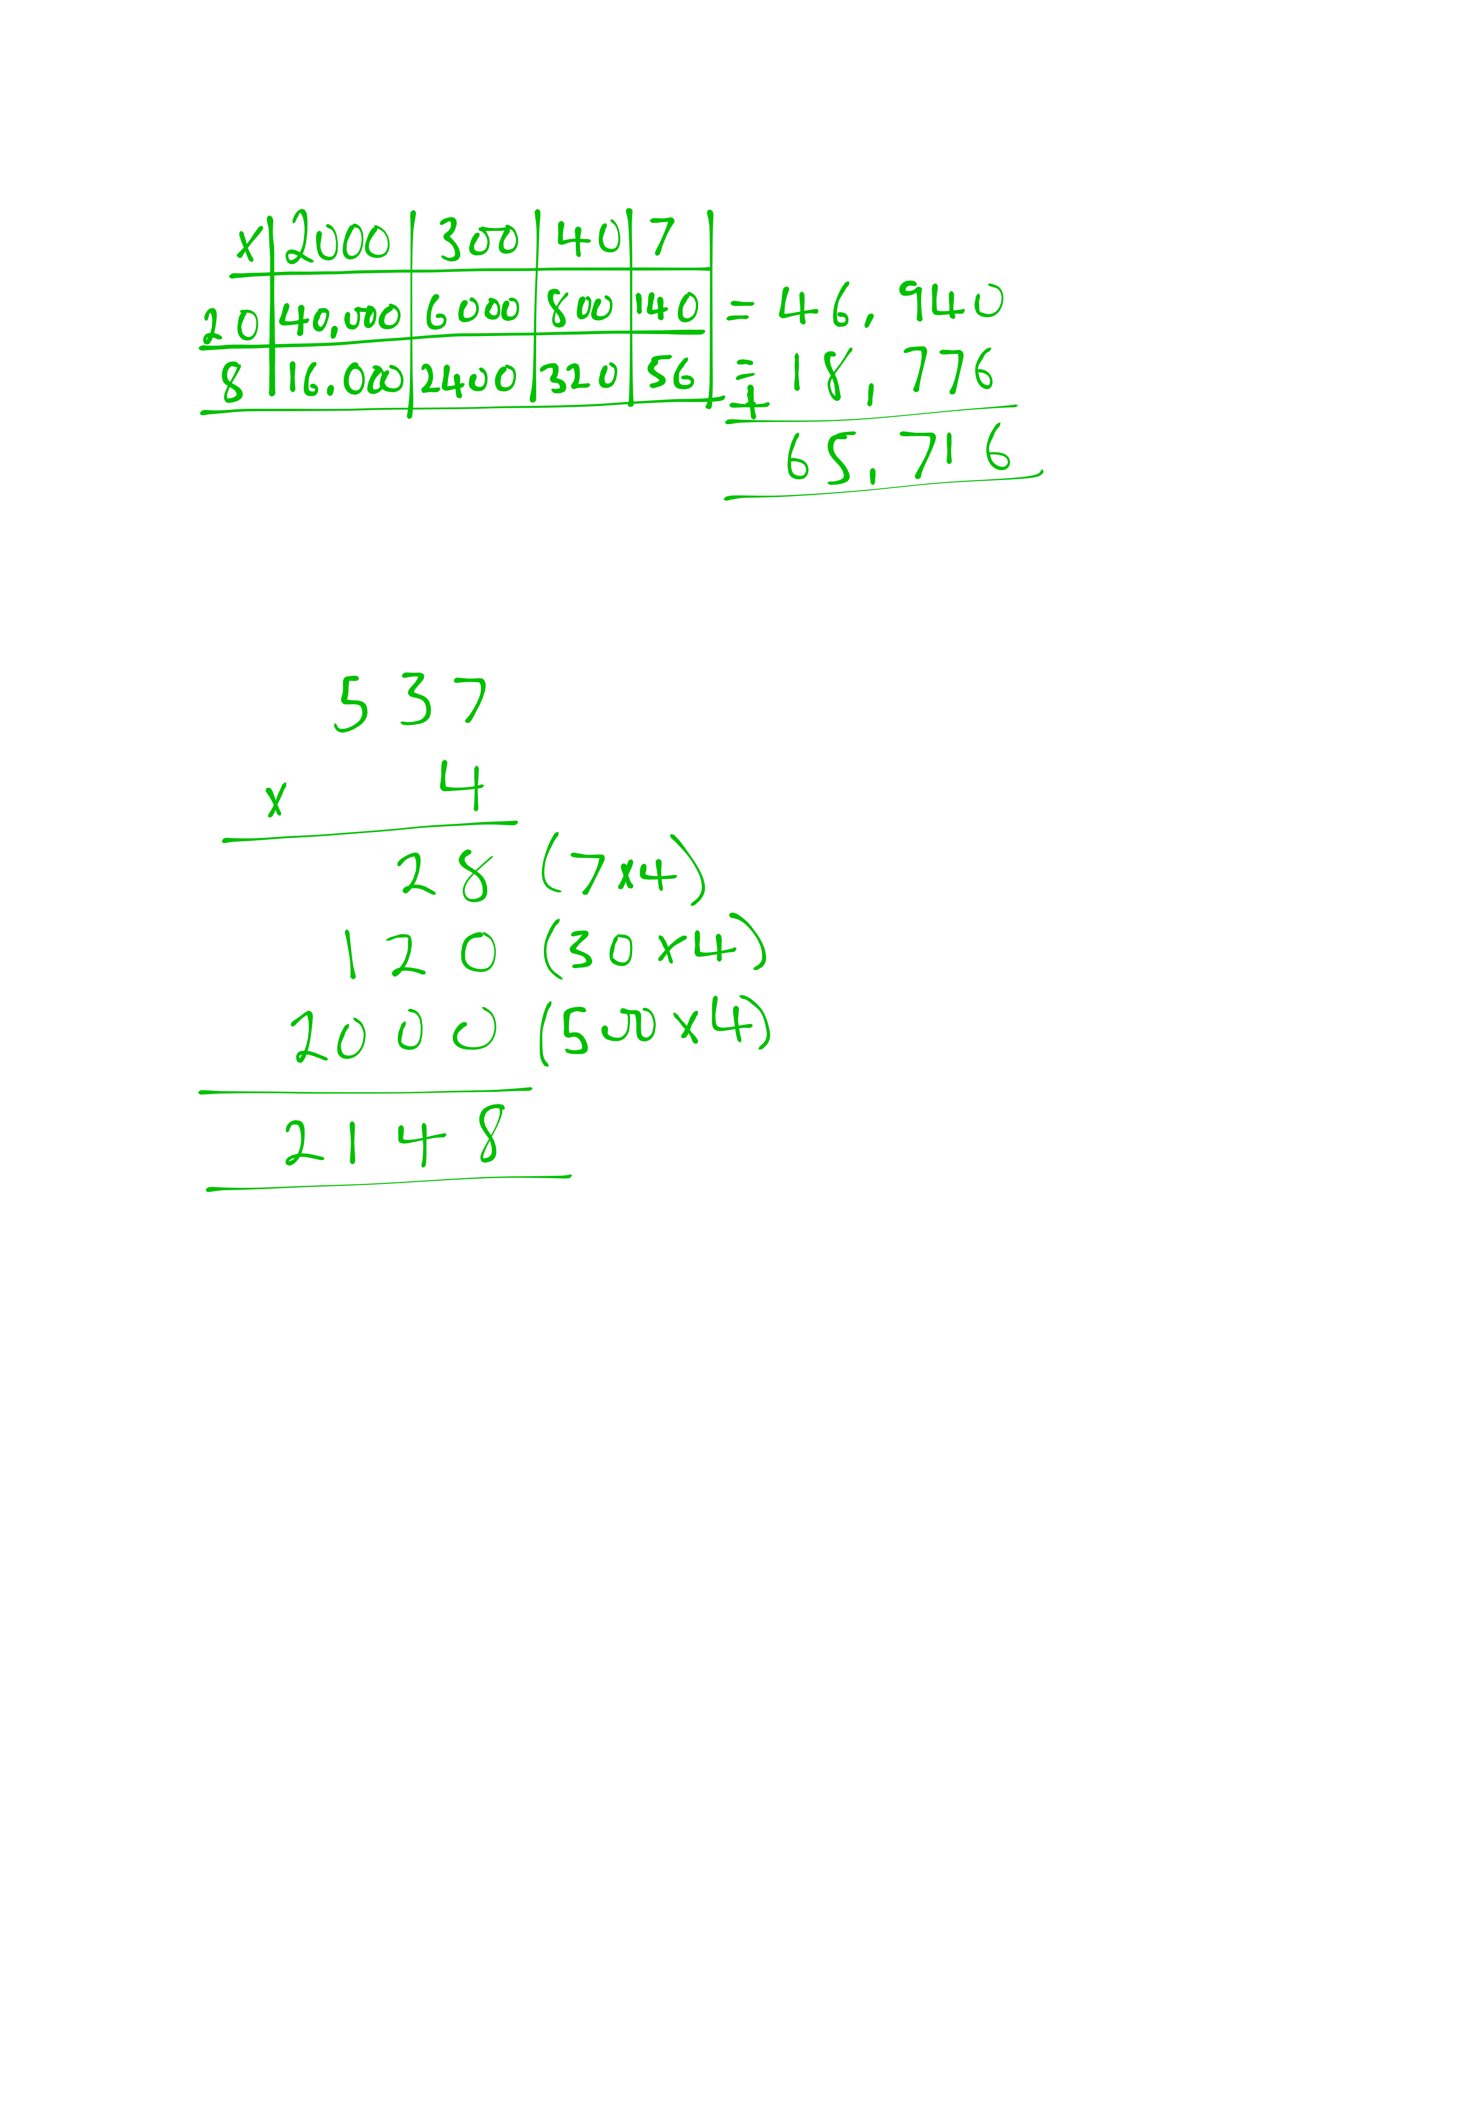 |  |  |  |  | Compact vertical |  |  |  | Bar Visualisation |  | Revise facts to 12 x 12  Square numbers  Cube numbers  Deduce primes to 100  Whole numbers x 10,100,100 |  | Multiply numbers using know facts
  537 | 537 | 537 | 537
  ?
Y6 | Use efficient methods:  Large Integer x U  (e.g 2347 x 28)  Large Integer x T U  (e.g 2347 x 84)  Decimal (upto2dp) x U  (e.g 3.62 x 7) | Grid method |  |  |  | Expanded vertical |  |  |  | Compact vertical |  |  |  |  | Bar method is not an efficient visualisation method in these examples |  | Rapid recall facts to 12 x 12  Square numbers  Cube numbers  Idedfity common primes, factor and multiples |  | Mental calculations including mixed operations and large numbers

