Rapid Recall
Mental calculation
Bar model
DIVISION AGE-RELATED
Recording

EXPECTATIONS
YR | Share objects into equal groups and count how many in each group | Practical / recorded using ICT (eg digital photos / pictures on IWB) |  | Pictures / Objects  6 cakes shared between 2  6 cakes put into groups of 2   |  |  |  |  | Symbols  6 cakes shared between 2  6 cakes put into groups of 2 |  |  | 6 shared into groups of 2 |  | (see recording)
KS1 | Solve (practical) problems that involve sharing into equal groups | Practical /  recorded using  ICT | Pictures / Symbols  How many apples in each bowl if I share 12 apples between 3 bowls? |  |  |  | Number tracks / Number line  (modelled using bead strings) 8 ÷ 2 = 4  9 ÷ 3 = 3  Counting in 3s  0 3 6 9 |  |  |  |  | 9  9 shared into 3 groups = 3 | Halves of even numbers to 10  (see recording)
  III | III | III
KS1 | Division as sharing and grouping (including remainders)  TU ÷ U  (where divisor is 2, 5 or 10)  Division is not commutative | Pictures / Symbols  Four eggs fit in a box. How many boxes would you need to pack 20 eggs? |  |  | Number lines / Arrays  15 ÷ 5  0 5 10 15  [ref Grouping ITP] |  |  |  |  |  | Partitioning  28 ÷ 2  20 ÷ 2 = 10  8 ÷ 2 = 4 | 25 ÷ 5 =  25 | Derive / recall ÷ facts for 2, 5 and 10 tables  Derive / recall halves of even numbers to 20 |  | TU ÷ 2,  TU ÷ 10 (multiples of 10)
  5 | 5 | 5 | 5 | 5
Lower  KS2 | TU ÷ U  (where divisor is 2, 3, 4, 5, 8 or 10)  Round remainders up / down, depending on the context | Number lines (start from zero)  33 ÷ 5 = 6 r3 (counting in 5s)  0 5 10 15 20 25 30 33 |  |  |  |  |  | Partitioning (multiples of the divisor)  50 ÷ 4 = 12 r2  10 x 4 = 40  2 x 4 = 8 (48)  [ref Number dials ITP] |  |  |  | 51  30  21  ÷3 ÷3  =10 = 7  10 + 7 = 17  51 ÷ 3 = 17 | Derive / recall ÷ facts for 2, 3, 4, 5, 8 and 10 tables  Derive / recall halves of numbers to 100  Find tenths (see fractions) |  | TU / HTU ÷ 2, 4,10, 5  ÷ 4 (halve, halve again)
Lower  KS2 | Record, support and explain:  TU ÷U  (eg 98 ÷ 6)  HTU ÷ U | Partitioning (multiples of the divisor)  67 ÷ 4 = 16 r3  10 x 4 = 40  6 x 4 = 24 (64) |  |  |  | Grouping/chunking (vertical layout)  96 ÷ 7 |  |  |  | 132  60  60  12  ÷ 6 = 10 132 ÷ 6 = 22  ÷ 6 = 10  ÷ 6 = 2 |  |  | Derive / recall ÷ facts up to the 12 times table |  | Numbers up to 1000 ÷ 10 / 100 (whole number answers and understand the effect)  Halves of TU / HTU numbers including decimals (1dp)

Estimate first  Y5 | Refine and use efficient methods:  ThHTU ÷ U  (eg 4123 ÷ 7) | Grouping (expanded) | Grouping (efficient)  Use tables fact and place value knowledge to support the fact that:  10 lots of 8 = 80  so,  further multiplying 80 by 4 = 320  (8 x 40 = 320)  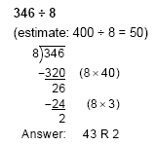 | ‘Short’ division  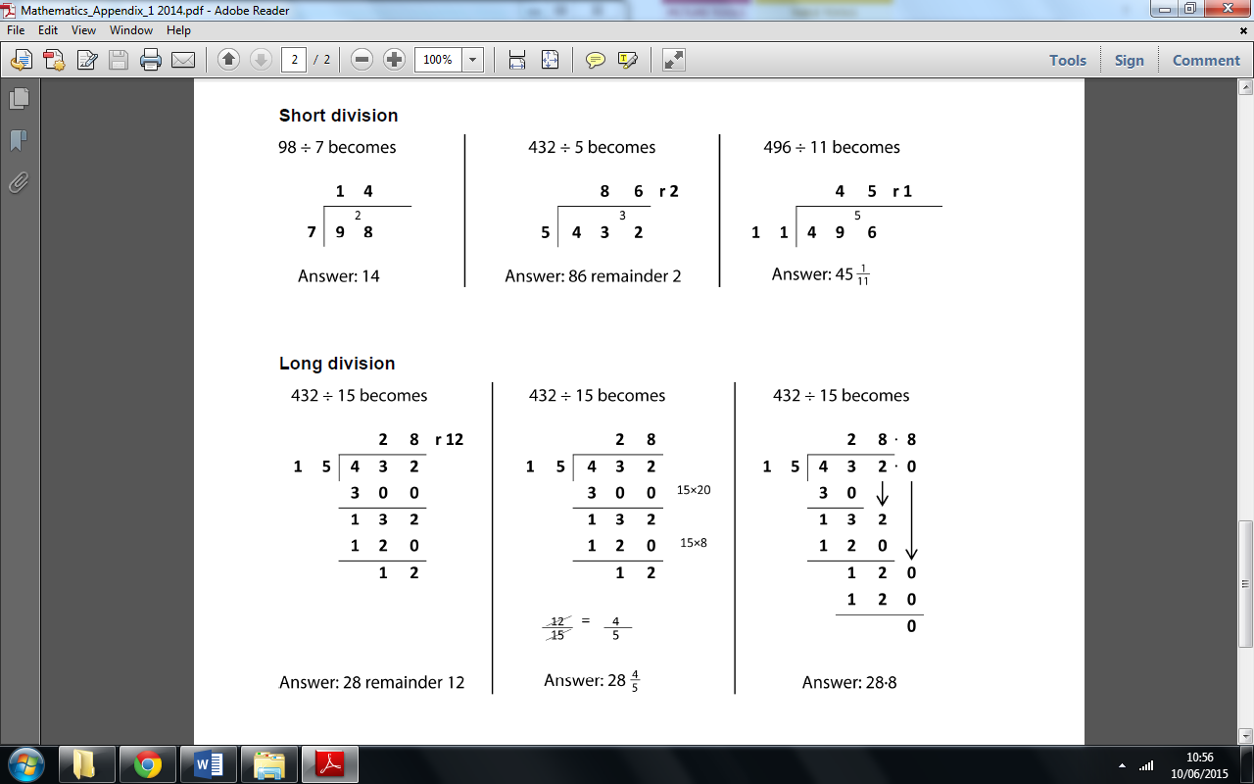  ²/₅  ^{Answer: 86 and 2 fifths} | Bar Visualisation | Recall quickly ÷ facts up to 12 times table  Divide whole numbers by 10, 100, 1000.
  432
Y6 | Use efficient methods:  ThHTU ÷ TU  (eg 4123 ÷ 27) | 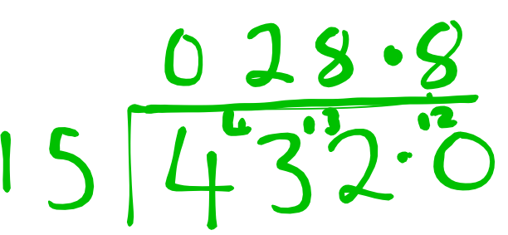  Grouping / Chunking (fractional remainder) or (decimal)  Use mental maths knowledge to support the fact that:  10 lots of 15 = 150  so, doubling it = 300  It may be useful to write multiples of 15 to assist. |  | Short/Compact/ ‘Bus-stop’ ((fractional remainder)  Support with Base 10 apparatus / deines equipment.  iPad app = “number pieces” | Bar Visualisation  Larger divisors make the Bar an inefficient visualisation method. | Factors  Divide decimals by 10, 100, 1000

