What your child will be learning this term.
If you would like more detail please talk to your child’s class teacher.

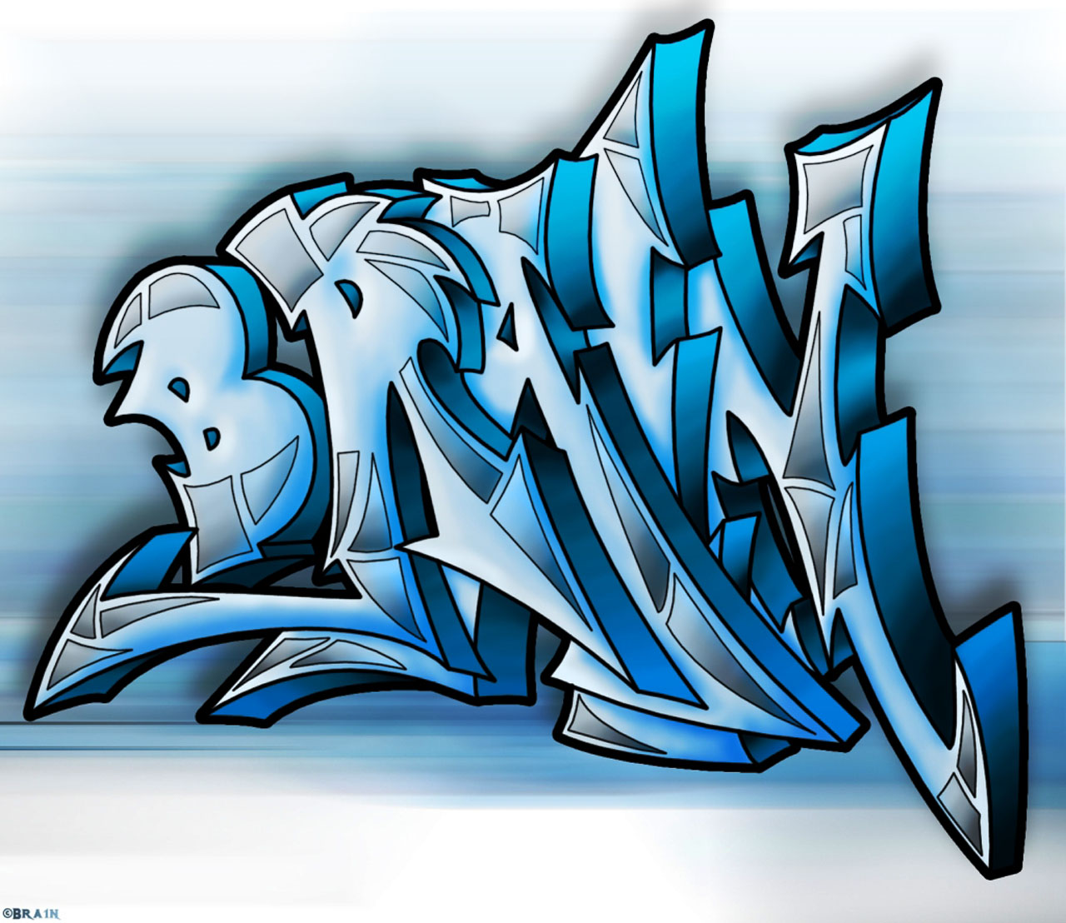



Understanding the World
We will be looking at weather and seasonal change.

Literacy
In Literacy we read books weekly and as part of mark making we have ‘Drawing Club’ which focuses on characters, settings and developing ideas. The focus this half term is celebrating who we are.

Expressive Arts and Design
We are painting and drawing ourselves as part of our art focus. We will use a range of media and mirrors to look at the details that make us unique.

Physical Development

Our morning activities are based around fiddly finger activities looking to develop our fine motor skills. This includes Dough Disco.
In PE, we will be looking at ball skills using our hands and our feet.

Communication and Language

This half term we are looking at questions and answers. We will be learning about what makes us similar and different to each other and give opportunities to share our ideas.

Personal Social and Emotional Development:
This half term we will be looking at ‘Being Me in My World’ as part of Jigsaw. We also look at our class charter and make rules together to make the classroom a happy learning environment.
We will be introducing games to practice taking turns, sharing and being a kind friend.

Foundation
Autumn 2024
All about me!

Mathematics
In Maths we are looking at Numbers 1-5 in a variety of ways including composition (making numbers), Counting and matching numeral and quantity.
Notes
PE days will be on a Monday. Reception to have a separate PE bag with PE uniform. Forest School on a Friday. Please come dressed in Forest School clothing.

