What your child will be learning this term.
If you would like more detail please talk to your child’s class teacher.

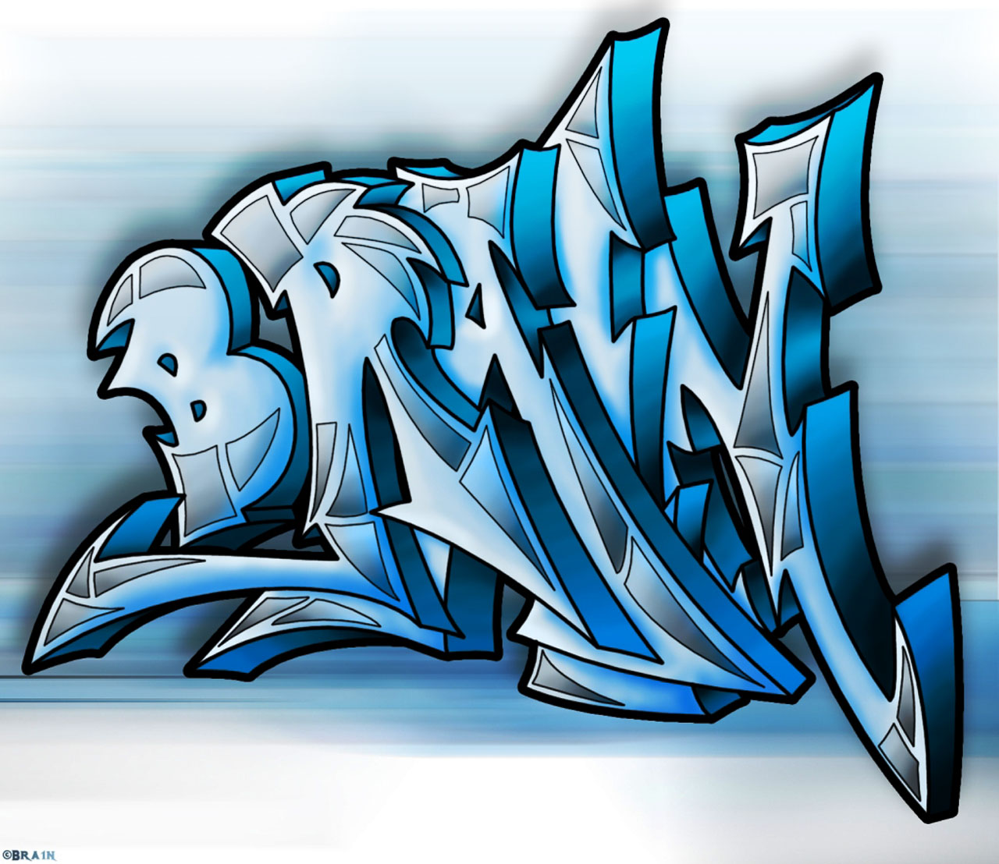

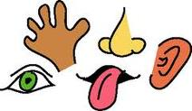


RE
The two questions we will focus on are: Christianity How does believing Jesus is their saviour inspire Christians to save and serve others? Islam Why do Muslims call Muhammad the ‘seal of the prophets?

Geography
The children are learning about Weather and Climate. They understand the difference between weather and climate, think about how weather is recorded and how climates change around the world.

Design Technology
This year the children will design a Christmas decoration and choose their best design to then create and evaluate.

Computing
The class will be looking at what a network is and how it works. They will then progress to learn about how networks support emails.

PE
This term Amazon Class will be working on problem solving strategies together using the equipment and will then progress to hockey.

Science
This term our topics will be Electricity, naming circuit parts, making simple circuits and applying this to ask questions about our environment. Our next topic is Changing states of Matter. The children will be able to describe the different processes that happen to change the state of matter and question whether states of matter can be reversed.
History
This term the children will be learning about the Stone Age to Iron Age. They will learn about the different materials of this time period and how they were used and how they are still used today. They also learn about village life during these periods.

English

This term we are using the Firework makers Daughter by Tony Pullman to write a narrative using a similar theme, instructions to make a firework (not a real one) and poetry to describe fireworks. The program we use to help the children is Pie Corbet which gives the children a scaffolded process that eventually they use independently.

Maths:
During the Autumn tern we will be doing Numbers to 1000 (yr3) and 10 000 (yr4), addition and subtraction, multiplication and division. We are using Maths No Problem which enables the children to challenge themselves in their thinking and vocabulary when solving -problems.

PSHE
This term we will complete work to develop our understanding of being ourselves in our world moving on to celebrating differences.

Year 3/4
Autumn 2024

Art

This term the children will be drawing portraits after looking at the work of Edgar Degas.
Notes

